Feasibility Study and Project Plan

Pinecrest People Mover

Members:

Ricardo Martinez

Maurice Pruna

Mentor:

Gabriela Wilson

Instructor:

Masoud Sadjadi

December 8, 2014

Florida International University School of Computing and Information Sciences

CIS 4911 U01

© 2014 by Senior Project – People Mover.

All rights reserved. No part of this document may be reproduced or transmitted in any form or by any means, electronic, mechanical, photocopying, recording, or otherwise, without prior written permission of Senior Project – People Mover.

# Abstract

This document is divided into four sections: Introduction, Feasibility Study, Project Plan, and the Appendix and References. The introduction provides information in regards to the project. This information consists of explaining the problem definition, which includes the desire, expectation, and goal provided by the client, gives a description of the project background, and provides a list of definitions and acronyms used in the document.

The feasibility study sections provides a description of any current system similar to our project, a proposition of the new system, the user requirements provided by the client, and any solutions that will aid in the development process. The project plan section provides an outline to the team personnel, the hardware and software resources needed for the project, and the work breakdown consisting of identifying tasks, milestones, and deliverables. Lastly, the document will have the appendix section, which consists of the project schedule in the form of a Gantt chart, the feasibility matrix, cost matrix, and the diary of the team meetings.

Table of Contents

Abstract 2

Introduction 4

1.1 Problem definition 4

1.2 Background 4

1.3 Definitions, Acronyms, and Abbreviations 4

1.4 Overview of document 4

Feasibility Study 5

2.1. Description of Current System 5

2.2. Purpose of New System 5

2.3. High-level Definition of User Requirements 5

2.4. Alternative Solutions 5

2.4.1. Description of Alternatives 6

2.4.2. Selection Criteria 6

2.4.3. Analysis of Alternatives 6

2.5. Recommendations 6

Project Plan 7

3.1 Project Organization 7

3.2 Project Personnel Organization 7

3.3 Hardware and Software Resources 8

3.4 Identification of Tasks, Milestones and Deliverables (work breakdown) 8

Appendix 10

4.1 Appendix A - Project schedule (Gantt chart or PERT Chart) 10

4.2 Appendix B – Feasibility Matrix 13

4.3 Appendix C – Cost Matrix 13

4.4 Appendix D - Diary of Meetings 14

References 17

# Introduction

## 1.1 Problem definition

The government of the village of Pinecrest would like to design a Web tracker and a Mobile tracker to show residents routes, hours of operation, real-time mover location (as a list and as an interactive map) and allow for automatic notifications for arrival at user’s favorite stops. The mobile tracker should work well on iPhone and android devices.

## 1.2 Background

The Pinecrest People Mover is a free transit bus service operated by the Village of Pinecrest connecting their neighborhoods and schools. It is mostly used by middle and high school students who do not qualify for bus service from the school district.

## 1.3 Definitions, Acronyms, and Abbreviations

App: Application

Mover: Pinecrest People Mover

SRS: Software Requirements Specification

UML: Unified Modeling Language

## 1.4 Overview of document

Chapter 2: Describes de feasibility study performed to select the solution to perform.

Chapter 3: Definition of the project plan which consists of the project organization which assigns roles to the team members and the project schedule. This chapter also contains the hardware and software requirements.

Chapter 4: Appendix. This chapter contains the project schedule, feasibility matrix, cost matrix and diary of meeting and tasks.

Chapter 5: References to other works.

Feasibility Study

## 2.1. Description of Current System

The village of Pinecrest has two mover routes that are currently operating as a free service (Palmetto Middle School and Palmetto Senior High School). Each one has a north and a south path. Pinecrest citizens mainly use the movers as alternative to get to the local schools. They have no way to know with precision the wait time for next mover while are waiting on a stop, or the nearest stop to their actual position. For that reason Pinecrest government is currently involved on the installation of GPS devices in the movers. A new system will be created to serve the clients desired purposes.

## 2.2. Purpose of New System

The main use of the movers is defined by the local schools schedule. Students use them as alternative to reach their school. The local government wants to provide a software application where their citizens could find information regarding the real-time position of the movers. This app is to be used as a tool to facilities the access to the local public transportation.

## 2.3. High-level Definition of User Requirements

The system will allow the user to:

* Find nearest stop
* Estimated arrival time of mover to stop
* See map routes
* See list route
* Define favorite stops
* Define final destination and receive notification
* Get default system alarms (out of service…)

## 2.4. Alternative Solutions

Our client requirement is for an application to work Android, iOs, and web environment. Therefore we could develop individual applications in native code. For all the solutions GoogleMaps API will be used as map engine for tracking the movers.

Our team analyzed the scenario of a future maintenance, expansion of the project to other systems, and the consistency of the interface among all the platforms.

Alternative 1: Design software applications for each platform:

* Android
* iOS
* Windows
* Web

Alternative 2: Design one web application with responsive design.

## 2.4.1. Description of Alternatives

The first alternative is geared to implement the same kind of application for each of the platforms listed. In this case we could have a personalized design taking to account the specifications for each platform. The interfaces would be different, creating some difficulties in the end user. The speed is important in order to get a proper tracking response, depending too much of the phones hardware requirements.

The second alternative would be one web application with responsive design that will work on all the platforms. After analyzing different frameworks we found given the real-time characteristic of this project we should select a framework that allow continuous calls without losing in functionality. Hence, to address this feature we found Sencha Touch framework that uses JavaScript, HTML5 and CSS3. Sencha Touch takes advantage of hardware acceleration to deliver an incredible application.

## 2.4.2. Selection Criteria

Given the characteristics of the problem, we wanted to handle a solution easy to implement, and easy to maintain. Designing the web application only, could reduce the time where the system could be functional for all the platforms. The maintenance time and cost would be reduced having a web only application. Also the interface will maintain the same format making easy to reproduce the same functionalities in any platform.

## 2.4.3. Analysis of Alternatives

|  |  |  |  |
| --- | --- | --- | --- |
| Feasibility Criteria | Weight | Alternative 1 | Alternative 2 |
| Operational Feasibility   * Functionality | 40% | Score: 40% | Score: 30% |
| Technical Feasibility   * Technology needed * Expertise needed | 40% | Score: 20% | Score: 30% |
| Schedule Feasibility   * Time to design and implement solution | 20% | Score: 10% | Score: 20% |
| Ranking | 100% | Score: 70% | Score: 80% |

## 2.5. Recommendations

Analyzing the characteristics of this project we recommend the use of Sencha Touch. The use of this technology will decrease the development time, also providing the possibility of future maintenance in a centralized system.

# Project Plan

This chapter will explain the schedule for the development plan. The roles of each team member are outlined in this section including their assigned roles. The hardware and software resources needed for the development of this project are also provided. Tasks, milestones, and deliverables are also outlined.

## 3.1 Project Organization

The team implementing this project consists of two students. Being the fact that the team is small, each team member will require having multiple roles, which include project manager, developer, tester, etc. The team members will have to use the resources allocated to them and must be approved by the client in order for the development of project to be a success

## 3.2 Project Personnel Organization

The structure of the project organization can be considered hierarchal. Each student will be in constant communication with each other during the development process. The students will be presenting their progress to Masoud Sadjadi, the professor, and Gabriela Wilson, the client. Masoud Sadjadi will be providing feedback to Ricardo Martinez and Maurice Pruna in how to improve project.

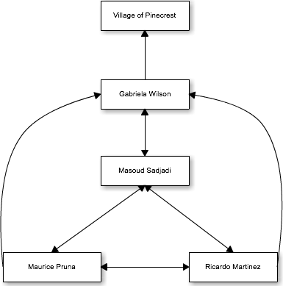

|  |  |  |
| --- | --- | --- |
| Name | Roles | Contact |
| Gabriela Wilson | Client/Mentor | gwilson@pinecrest-fl.gov |
| Masoud Sadjadi | Professor | sadjadi@cs.fiu.edu |
| Ricardo Martinez | Front-End Developer, Tester | rmart071@fiu.edu |
| Maurice Pruna | Back-End Developer, Tester | mprun003@fiu.edu |

## 3.3 Hardware and Software Resources

Required Hardware

* iOS device
* Android device
* Server

Required Software

* Microsoft Word
* Cacoo
* Microsoft Project
* GitHub
* Trello
* SourceTree
* FIU Moodle

## 3.4 Identification of Tasks, Milestones and Deliverables (work breakdown)

|  |  |  |  |  |
| --- | --- | --- | --- | --- |
| ID | Task Name | Duration | Start | Finish |
| 1 | Meet with Partner |  |  |  |
| 2 | Meet with mentor |  |  |  |
| 3 | Create high level requirements |  |  |  |
| 4 | UI Mockup Designs |  |  |  |
| 5 | Create Use Cases |  |  |  |
| 6 | Create Schedule |  |  |  |
| 7 | Use Case Diagrams |  |  |  |
| 8 | Requirements Document |  |  |  |
| 9 | Project Plan Document |  |  |  |
| 10 | Feasibility Study |  |  |  |
| 11 | Hardware & Software Specifications |  |  |  |
| 12 | Retrieval of client server and database information |  |  |  |
| 13 | Begin Implementations |  |  |  |
| 14 | Design Test Cases based on use case criteria |  |  |  |
| 15 | Present to client product |  |  |  |
| 16 | Present project to class |  |  |  |

|  |  |
| --- | --- |
| Milestones | Projected Date |
| Finalized Requirements Document | 9/22/14 |
| Finalized Design Document | 10/13 |
| Completion of Implementation | 11/28/14 |
| Testing Phase Completed | 12/4/14 |
| Final Deliverable | 12/11/14 |
| Provide finished product to client | 12/12/14 |

# Appendix

## 4.1 Appendix A - Project schedule (Gantt chart or PERT Chart)

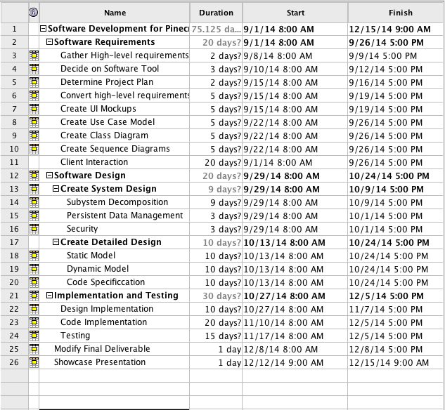

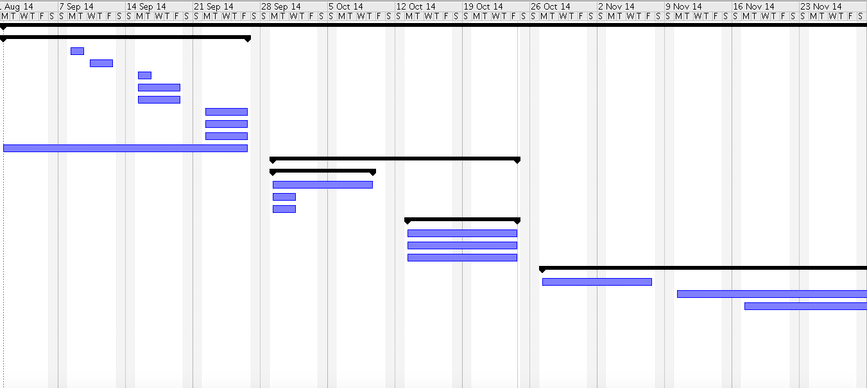

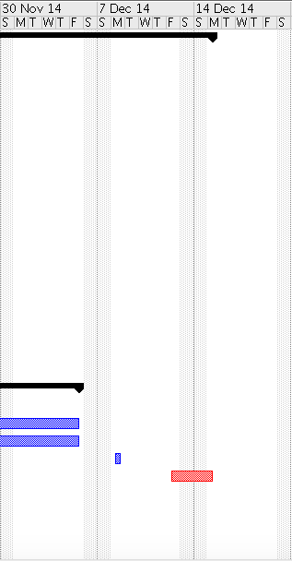

## 4.2 Appendix B – Feasibility Matrix

|  |  |  |  |
| --- | --- | --- | --- |
| Feasibility Criteria | Weight | Alternative 1 | Alternative 2 |
| Operational Feasibility   * Functionality | 40% | Score: 40% | Score: 30% |
| Technical Feasibility   * Technology needed * Expertise needed | 40% | Score: 20% | Score: 30% |
| Schedule Feasibility   * Time to design and implement solution | 20% | Score: 10% | Score: 20% |
| Ranking | 100% | Score: 70% | Score: 80% |

## 4.3 Appendix C – Cost Matrix

|  |  |
| --- | --- |
| Human resource | Work(hours) |
| Ricardo Martinez | 360 |
| Maurice Pruna | 360 |

|  |  |  |
| --- | --- | --- |
| Non-human Resources | Quantity | Cost |
| Computers | 2 | $0.00 |
| Server | 1 | $0.00 |
| Apache Server | 1 | $0.00 |
| Apache Tomcat | 1 | $0.00 |
| Spring Framework | 1 | $0.00 |
| Spring Tool Suite | 2 | $0.00 |
| MYSQL | 1 | $0.00 |
| Sencha Architect, Sencha Cmd | 1 | $0.00 |

## 4.4 Appendix D - Diary of Meetings

Meeting 1

|  |  |
| --- | --- |
| Date: | Wednesday, September 3, 2014 |
| Location: | Google Hangouts |
| Start time: | 8:00 pm |
| End time: | 8:30 pm |
| In Attendance: | Ricardo Martinez, Maurice Pruna |
| Agenda: | 1. Introduction to Teammates |
|  | 2. Discuss ideas and gather information of what may be needed for the project. (use Miami-dade transit website as reference) |
|  | 3. Go over information in regards to PineCrest Mover |
| Assigned Tasks: |  |
|  | 1. Meet September 4, 2014 at FIU |
|  |  |

Meeting 2

|  |  |
| --- | --- |
| Date: | Wednesday, September 4, 2014 |
| Location: | FIU, JCCL Lab |
| Start time: | 8:15 pm |
| End time: | 9:00 pm |
| In Attendance: | Ricardo Martinez, Maurice Pruna |
| Agenda: | 1. Gather questions for tomorrow’s conference call with mentor |
|  | 2.Share bootstrap and Google maps API resources |
|  | 3. Go over what is needed in document and feasibility matrix |
| Assigned Tasks: |  |
|  | 1. Meet September 5, 2014 for conference call 12:30pm – 1:30 pm |
| Duration: | 45 minutes |

Meeting 3

|  |  |
| --- | --- |
| Date: | Friday, September 5, 2014 |
| Location: | Conference Call |
| Start time: | 12:30 am |
| End time: | 1:30 pm |
| In Attendance: | Gabriela Wilson, Ricardo Martinez, Maurice Pruna |
| Agenda: | 1. Problem discussion and identification of possible users   * Agreed to start a Web/Mobil app * Defined guest user for general interaction * Defined registered user for “favorite bus stop” * Extra tool requested to manage routes and buses. |
|  | 2. Defined status of the GPS devices on the movers.   * Identified Trolley Company as the source of GPS data. |
|  | 3. Identified similar applications from other local governments. |
|  |  |
| Assigned Tasks: | 1. Create mock ups design 2. Define use cases 3. Contact the trolley company to define the data retrieval |
| Duration: | 60 minutes |

Meeting 4

|  |  |
| --- | --- |
| Date: | Saturday, September 6, 2014 |
| Location: | FIU, JCCL Lab |
| Start time: | 10:30 pm |
| End time: | 4:30 pm |
| In Attendance: | Ricardo Martinez, Maurice Pruna |
| Agenda: | 1. Begin Feasibility Study document |
|  | 2.Begin Project Plant document |
|  | 3.Discuss best approach for implementation of project |
| Assigned Tasks: |  |
|  | 1. Meet September 7, 2014 10:30 AM at FIU |
| Duration: | 6 hours |

Meeting 5

|  |  |
| --- | --- |
| Date: | Sunday, September 7, 2014 |
| Location: | FIU, JCCL Lab |
| Start time: | 11:00 pm |
| End time: | 4:45 pm |
| In Attendance: | Ricardo Martinez, Maurice Pruna |
| Agenda: | 1. Think of specifications |
|  | 2.Begin Specifications doc |
|  | 3.Discuss best approach for implementation of project |
| Assigned Tasks: |  |
|  | Submit first revision documents |
| Duration: | 5 hours 45 minutes |

Meeting 6

|  |  |
| --- | --- |
| Date: | Tuesday, September 9, 2014 |
| Location: | FIU, JCCL Lab |
| Start time: | 6:30 pm |
| End time: | 8:00 pm |
| In Attendance: | Ricardo Martinez, Maurice Pruna |
| Agenda: | 1. Check Requirements Feedback |
|  | 2. Work on the mockups design |
|  |  |
| Assigned Tasks: | Continue working on the mockups |
|  | Improve use cases model |
| Duration: | 90 min |

Meeting 7

|  |  |
| --- | --- |
| Date: | Wednesday, September 10, 2014 |
| Location: | Conference Call |
| Start time: | 12:00 am |
| End time: | 12:30 am |
| In Attendance: | Ricardo Martinez, Maurice Pruna, Gabriela Wilson |
| Agenda: | 1. Check Requirements |
|  | 2. Check mockups design updates |
|  | 3. Check business workflow |
|  | 4. Status of the TSO api and GPS devices |
| Assigned Tasks: | Continue working on the mockups |
|  | Improve use cases model |
| Duration: | 30 min |

# References

<http://www.sencha.com/>

<http://www.sencha.com/forum/>

<http://spring.io/>

<http://www.sublimetext.com/>

<https://cacoo.com/diagrams/>

<https://developers.google.com/maps/documentation/javascript/tutorial>

<http://phonegap.com/blog/2013/11/20/SenchaPhoneGap/>